Mrs. Tropeano’s Kindergarten Korner
May 14, 2021
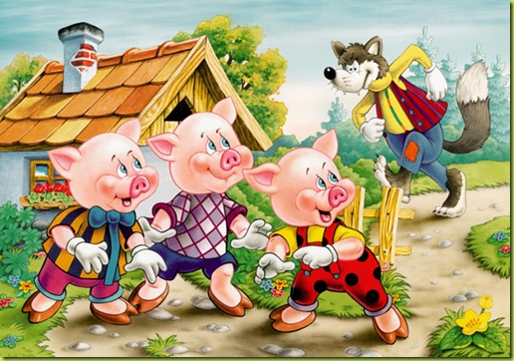

Integrated Language Arts
This week we began our unit on Fairy Tales. We talked about fairy tales being stories filled with magical and imaginary characters that are meant to entertain. Our unit began with the story of “The Three Little Pigs.” The children listened to a few different versions of the story. One of their favorites was written by Steven Kellogg and depicted the three little pigs happily working in their family business making the best tasting waffles in the world.
In Writer’s Workshop we have circled back to our first unit in which the children are writing about topics they know all about. It is fun and rewarding to see how far they have come in their writing skills since the beginning of the school year. In conjunction with our discussion of the Three Little Pigs and the Big Bad Wolf, we also spent some time writing a prediction about what could be blown the farthest: a feather, a bouncy ball, or a golf ball.

Centers
*Book Club-listened to the story “Lion and the Mouse” and answered comprehension questions.
*Discover- cut out, sorted, and glued pictures according to their beginning sound (r or s).
*ABC-color, cut, and glued pictures that belong in the -ap and -at families.
*Handwriting-practiced proper formation of upper and lowercase Ss, first and last name, and labeled pictures that begin with S.
*Science-Huff and Puff Experiment- predicted which object would move the furthest and why: a bouncy ball , feather or golf ball.
*Writing- dictation- stretched out and wrote short i words and wrote the sentence “The wig was big.” Completed the red word drill for the word “want.”
*Book Basket- colored, cut, and glued to create the Three Little Pigs’ Houses.
*Poetry- illustrated the poem “Hickory Dickory Dock” and identified high frequency words.
*Math- completed pig addition sentences by counting and coloring the Three Little Pigs.
*Religion- colored, cut, and glued to make a picture honoring our Mother, Mary.
Math
This week we completed chapter 10 on Classifying Position. We talked about the words beside, next to, above, and below. Students drew objects in the correct position according to directions.
Religion
This week we discussed the importance of Sunday within our church family and our home family. We talked about how attending mass on Sunday shows God just how much we love him. We continued to talk about, pray to, and sing songs about our Mother Mary as we honor her in this month of May.

Odds and Ends
*Thank you for your continued support
*Friday, May 28th-No School Bishop’s Holiday
*Monday, May 31- No School Memorial Day
*Have a wonderful weekend! God Bless!

